William M. Matthews Ed.D., M.A., B.S. 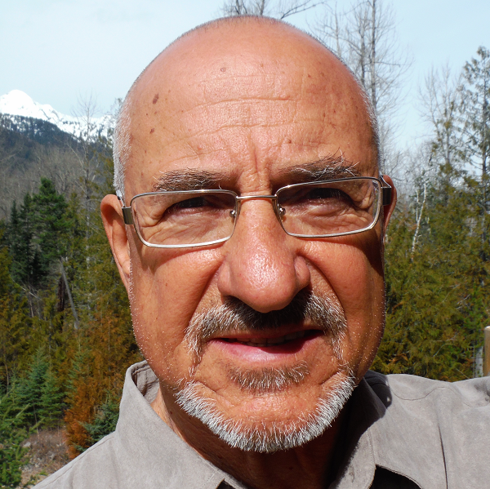

PO Box 1985
Fernie, BC, Canada
V0B 1M0
Phone: (250) 430 7938

E-Mail: mattdrwill@hotmail.com

INTERESTS:
Rapid Response Assessment, Disaster Preparedness and Planning, Resilient Communities/ Psychosocial Integrated Programming

SKILLS SNAPSHOT:
Field Operations Team Leader Trainer/Educator
Planner/Developer/Evaluator Psychologist
Program Director/Administrator

Recent Relevent Experiences:
- Planner/Consultant, Emergency and Disaster Management Development, Fernie B.C. 2013-present. Team leader of planning work group. Design and development of Emergency Management capacity at the community level.
- Search and Rescue, Ground Search Team Leader, Fernie and Area, 2008-present. Numerous search and rescue missions in Canadian Rockies.
- Associate Faculty and Program Developer, Masters of Arts in Disaster and Emergency Management, Royal Roads University, BC, Canada 2008-2012. With three associates, designed, developed and was a professor in the MADEM program.
- Developer: Red Cross National Worker Care Plan, CRCS, 2005. Designed, developed and provided initial training in a program for worker care presently used throughout the CRCS.
- Consultant /Program Developer: Principles Based Program Integration, CRCS, Sri Lanka and Indonesia, 2005 Provided consultation in developing programing after the SE Asian Tsunami consistent with RC principles and resilient communities concepts.
- Manager, Disaster Resilient Communities Programs, Canadian Red Cross Society (Western Canada) 2005-2007. Designed and developed “resilient communities” concepts and protocols for integration into community disaster response and recovery capacity. Provided training and consultation at the provincial, regional and community level as a part of disaster preparedness.
- Consultant/Trainer, Community Resiliency/Disaster Preparedness, Cuban Red Cross, Havana, Cuba 2005 Conducted training, seminars and presentations as a part of transition of Psychosocial protocols to community empowerment models of “resiliency”.
- Evaluator, Ghana Red Cross, Psychosocial Needs and Capacity Assessment, 2004 Community assessment and consultation resulting in a plan to expand community involvement as active partners in emergency and disaster preparedness.
- Coordinator/Program Developer, Disaster Mental Health, Department of Health, New Mexico, 2004 Designed psychosocial protocols consistent with community resiliency models of disaster response and recovery. Integrated models as a part of overall planning for all hazards response.
- Psychologist/Social Welfare Delegate, International Federation of the Red Cross and Red Crescent Societies ( Turkey) 2002-2003 Team leader in the recover process with the Turkish Red Crescent after the Marmara earthquake. Psychosocial lead in developing protocol for the TRC with integration via training and consultation in the development of refugee camps on the Syria and Iraq border at the outset of the war. Responded as psychosocial team lead at the Bingu earthquake.
- Manager, Psychosocial Sector, International Services, American Red Cross (Washington D.C.) Designed psychosocial protocols as an integrated component of disaster preparedness, response and recovery for ARC international initiatives. Provided rapid assessment, consultation, training, program development, project evaluation and worker support. Direct service included field experiences in El Salvador, Guatemala, Venezuela, Bulgaria, India, Kosovo /Macedonia. 2001-2002

- Psychologist/Psychosocial Delegate, International Federation of the Red Cross and Red Crescent Societies (Kosovo) 2000-2001 Community recovery /psychosocial team lead responsible for a region of some 32 villages and 72000 persons. With a team of three para-professional workers from the Kosovo Red Crescent identified, trained and coordinated over 400 volunteers directed at recovery efforts.

PAST PROFESSIONAL EXPERIENCES:
- Co-founder/Vice President: Alternatives Associates Inc. (Psychological Consultation), Albuquerque, New Mexico
- School Psychologist, Las Vegas City Schools, New Mexico
- Director, Center for Adolescent Rehabilitation and Education, Las Vegas Medical Center, New Mexico
- Bureau Chief, Mental Health Bureau, Health and Environment Department, State of New Mexico
- Director, Forensic Systems, Health and Environment Department, Santa Fe, New Mexico
- Manager, Wilderness Experience Program (Now Santa Fe Mountain Center), Santa Fe , New Mexico
- Clinical Director, Forensic Hospital, Department of Hospitals and Institutions, Santa Fe, New Mexico
- Psychologist, Pre-prosecution Diversion Program, District Attorney’s Office, Greeley, Colorado
- Psychologist/Program Developer, Exploration Bound, Educational and Psychological Consultation, Greeley, Colorado
- Coordinator, Adult Basic Education, Jackson Public Schools, Jackson, Michigan
- Teacher/Consultant, Michigan Migrant Education Program, Region III, Van Buren Intermediate School Districts, Pau-Pau, Michigan

Background:
- Permanent Resident, Canada (citizenship status pending)
- Licensed Psychologist (California & New Mexico)
- Diplomat, American Board of Forensic Examiners (Psychological Evaluation and Assessment)
- Doctoral program majors: Counseling Psychology, Alternative Educational Systems, and Community Organization
- Masters program majors: Multicultural and Multiethnic Education
- Bachelors program majors: Psychology and Sociology
- Recent training received: First Aid (OFA) level 1, EOC Basic, Emergency Plan Development, EOC Operations level 1-3, EOC Planning level 1-2, ESS Basic, Search and Rescue (GSAR, Tracking, Swift Water Rescue, SAREX 2013-2015)

References available on request

